Project Design Phase-II Technology Stack (Architecture & Stack)

|  |  |
| --- | --- |
| Date | **03October 2022** |
| Team ID | **PNT2022TMID34760** |
| Project Name | **Gas Leakage Monitoring And Alerting System** |
| Maximum Marks | **4 Marks** |

Technical Architecture:

The Deliverable shall include the architectural diagram as below and the information as per the table1 & table 2

Example: Order processing during pandemics for offline mode

Reference: <https://developer.ibm.com/patterns/ai-powered-backend-system-for-order-processing-during-pandemics/>

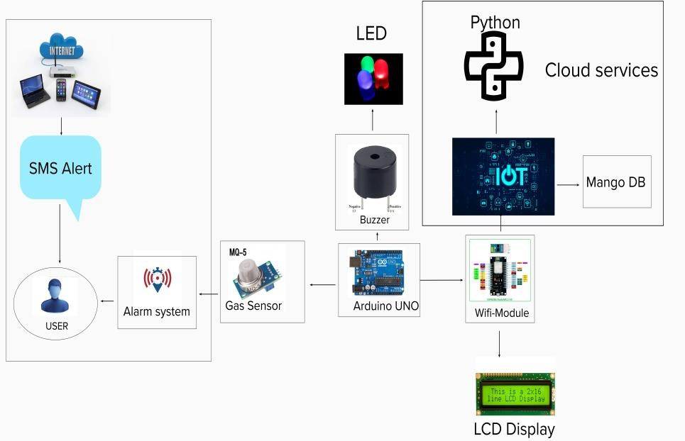

Guidelines:

1. Include all the processes (As an application logic / Technology Block)
2. Provide infrastructural demarcation (Local / Cloud)
3. Indicate external interfaces (third party API’s etc.)
4. Indicate Data Storage components / services
5. Indicate interface to machine learning models (if applicable)

Table-1 : Components & Technologies:

|  |  |  |  |
| --- | --- | --- | --- |
| **S.No** | **Component** | **Description** | **Technology** |
| 1. | MQ-5 gas sensor | Used to detect toxic or explosive gasses and measure gas concentration | Detecting , humidity |
| 2. | ESP8266 WIFI Module | Capable of either an application or offloading all  WI-FI networking functions from application processor. | Integrated TCP/IP Protocol stack. |
| 3. | LED | Two lead semiconductor light source | Pn -junction diode ,which emits light when activated. |
| 4. | Buzzer | It is an audio signalling device. | Timers and confirmation of user input such as a mouse |
| 5. | Arduino uno | Open source electronics platform based on easy to use hardware and software | Integrated development environment(IDE) |
| 6. | Cloud services | Database Service on Cloud | IBM DB2, IBM Cloudant etc. |
| 7. | Python code | Computer programming language often used to build websites and software | Multi-paradigm programming language |
| 8. | User application | Purpose of External API used in the application | IBM Weather API, etc. |
| 9. | Specified mobile number | Login, looking website basic details | Application etc. |
| 10. | Internet | Networks interlinked | Worldwide system of computer  networks |
| 11. | Mango db | Open source database management program. | Open-source document database. |

Table-2: Application Characteristics:

|  |  |  |  |
| --- | --- | --- | --- |
| **S.No** | **Characteristics** | **Description** | **Technology** |
| 1. | Open-Source Frameworks | Leaks indicators developing ,electronics rador | Feed actual time sensor data internet |

|  |  |  |  |
| --- | --- | --- | --- |
| **S.No** | **Characteristics** | **Description** | **Technology** |
| 2. | Security Implementations | Increasing due to an attack surface having data Leakage detection in place a key. | Continuous monitor your external attack surface. |
| 3. | Scalable Architecture | Requirements necessity for detection. | Technology used |
| 4. | Availability | High quality instruments that can locate the leaks | Technology used |
| 5. | Performance | Arduino response time will be fast | Technology used |

References:

<https://c4model.com/>

<https://developer.ibm.com/patterns/online-order-processing-system-during-pandemic/> <https://www.ibm.com/cloud/architecture>

<https://aws.amazon.com/architecture>

<https://medium.com/the-internal-startup/how-to-draw-useful-technical-architecture-diagrams-2d20c9fda90d>